**Article Portfolio Assignment 1: Due _____________ NAME: ___________________________**

**DIRECTIONS:** You will select TWO articles to read with the accompanying assignment. One article will address SOAPSTone, and the other one will address main ideas/supporting evidence. **NOTE**: If you are absent the day the work is due, you must email it by the start of class (take pics of your annotated articles and email the word doc with your questions/explanations of correct answers).

**ASSIGNMENTS:**

**ARTICLE 1: SOAPSTone:**

1. Close-read your article. Label elements of SOAPSTone—highlight **and make margin notes to explain elements briefly**.
2. Type and print THREE multiple choice questions (as noted below), AND include an explanation of the correct answer:

* One question on purpose. Include 4 answer choices, the right answer, and an explanation of the correct answer.
* One question on tone. Include 4 answer choices, the right answer, and an explanation of the correct answer.
* One question on *speaker OR occasion OR audience*. Include an explanation of the correct answer. Include 4 answer choices, the right answer, and an explanation of the correct answer.

**🡺Sample PURPOSE questions:**

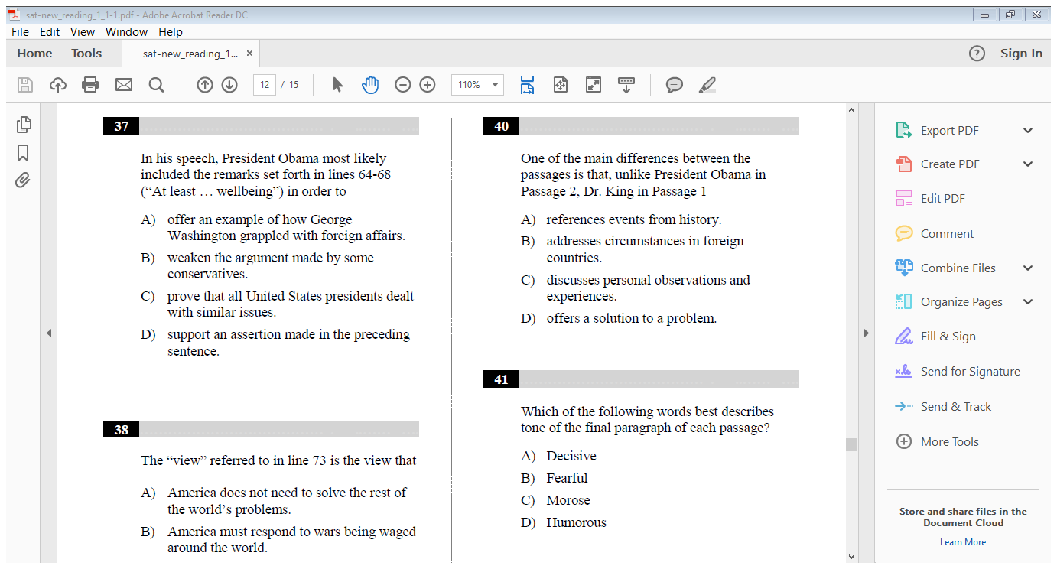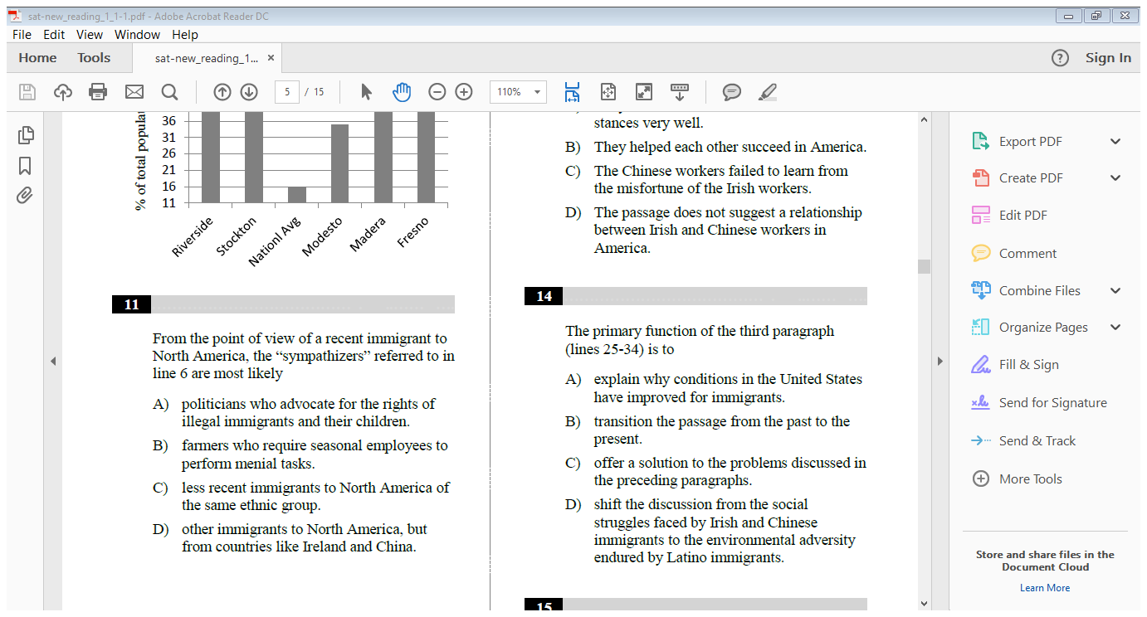

**🡺Sample TONE Question:**

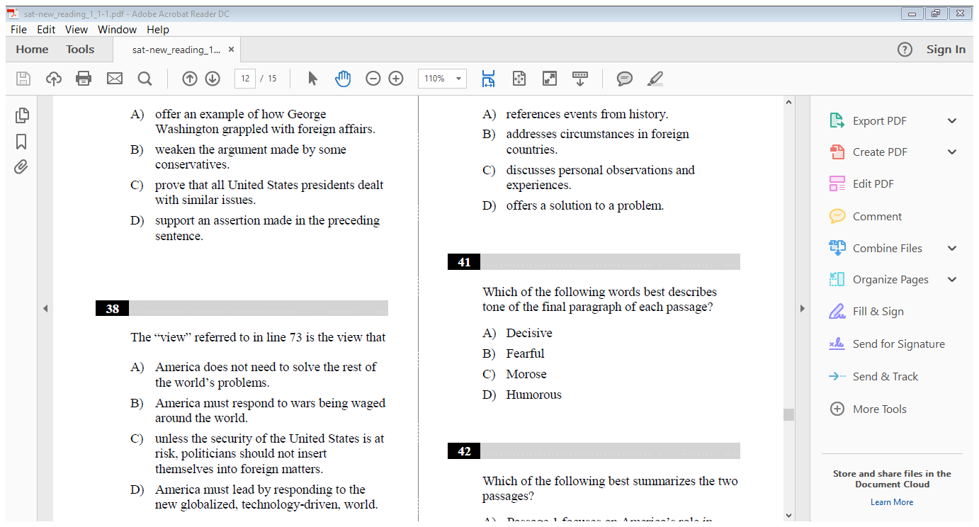

**ARTICLE 2: MAIN IDEAS/SUPPPORTING EVIDENCE:**

1. Close-read your article. Label the main idea, and in the margin, paraphrase the main idea in your own words.
2. Find at least 3 pieces of evidence to support the main idea, and highlight them. In the margin, paraphrase the supporting details in your own words.
3. Create/type and print one multiple choice question about either the main idea/key fact ***or*** a piece of evidence that supports the main idea/key fact. Include 4 answer choices, the right answer, and an explanation of the correct answer.

**🡺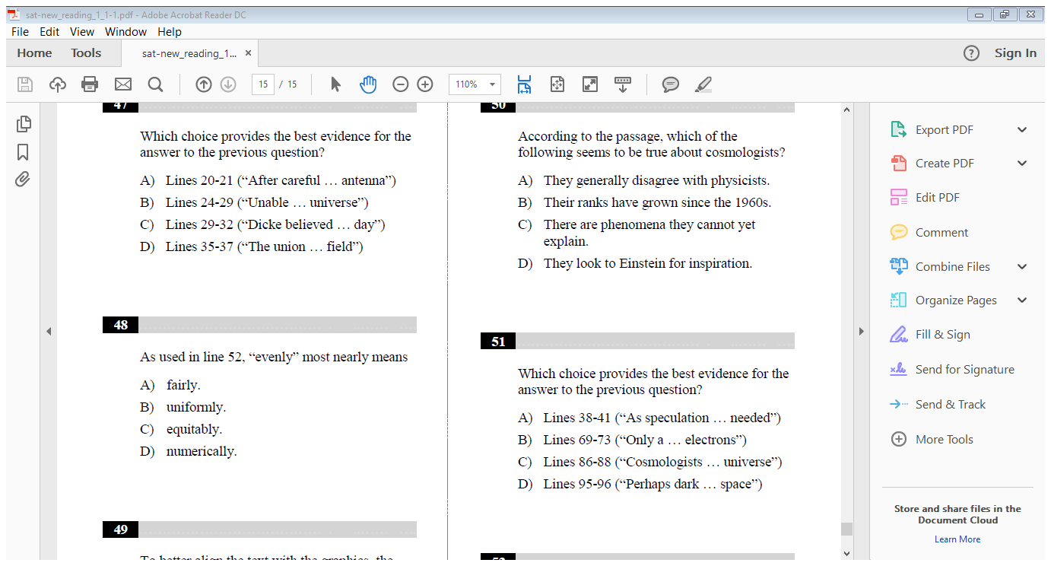Sample Questions**:



**🡺 MORE Sample Questions**

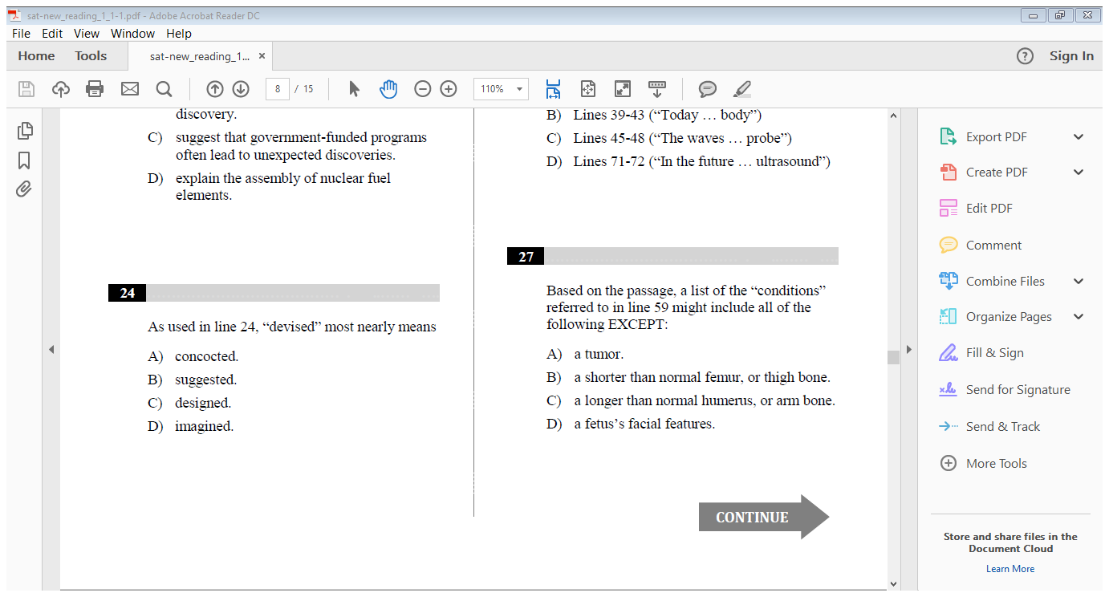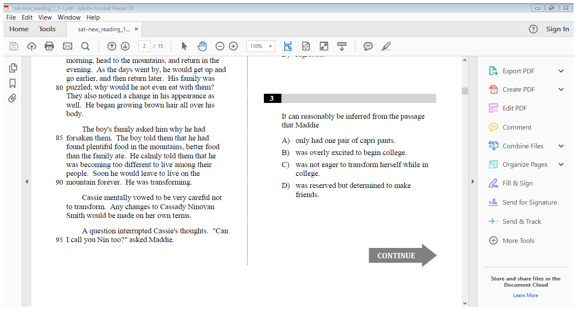

**RUBRIC**

**REMINDERS:**

* You must highlight—not pencil mark or underline—your sources. Get yourself a highlighter!
* If I cannot read your annotations, you do not get credit. (You can copy/paste articles into Word documents and type annotations/margin notes).
* Did you include the basic MLA info on your sources?
* Finally, remember to type your questions/explanations.
* Save this rubric to submit with your work.
* If you are absent, email all work by the start of class.

**Article annotations-SOAPSTone ✓+ ✓ ✓-**

* Thorough
* Accurate
* Insightful
* Complete

**Article annotations-main idea/supporting details ✓+ ✓ ✓-**

* Thorough
* Accurate
* Clear, insightful paraphrases
* Complete

**Questions and Explanation (typed) ✓+ ✓ ✓-**

* 4 questions total
* Clear, thoughtful questions modeled after real SAT questions
* Answer choices reflect a need *to think* to select the most correct choice
* Answer explanation is clear and supported with text references/logic
* Correct grammar/mechanics

**TOTAL**: /20 points